The H2+ molecule-ion

by Reinaldo Baretti Machín
www.geocities.com/serienumerica
e-mail : reibaretti2004@yahoo.com

References:
1.Linus Pauling & E. Bright Wilson, Introduction to Quantum Mechanics , Dover Publications, chapter XII.

A one dimensional model of the H2+ molecule ion is presented, that reproduces the essential features of this most simple of all molecules.

The two hydrogen atoms are located at x= 0 and at x= R.
We solve numerically the equation (see the FORTRAN code below)

{ -(1/2) ∆ - 1/x - 1 / abs(x-R) +1/R } Ψ = ε Ψ (1)

We assume that V(x) = ∞ for x ≤ 0 , and for x ≥ R.
The boundary conditions on Ψ are

Ψ (0) =0. dΨ(0)/dx =1. , Ψ( R )=0.

Figure 1 shows our results. The binding energy (in au) is
-.84 – the energy at (R= infinty) = -.84-(-.5) = -.34 au
The equilibrium distance is 2.5 au.

Figure 2 ( from the quoted reference) employs Rydberg units.
The conversion is 1 Ry = (1/2) au .

From that plot the binding energy is near
-.20 Ry = -.10 au.The equilibrium distance is 2.0 au.

energy of H2+ molecule-ion
Figure 1
-1.5
-1
-0.5
0
0.5
1
1.5
2
2.5
3
0
1
2
3
4
5
6
7
8
9
10
R (au) internuclear distance
E (au)
Series1

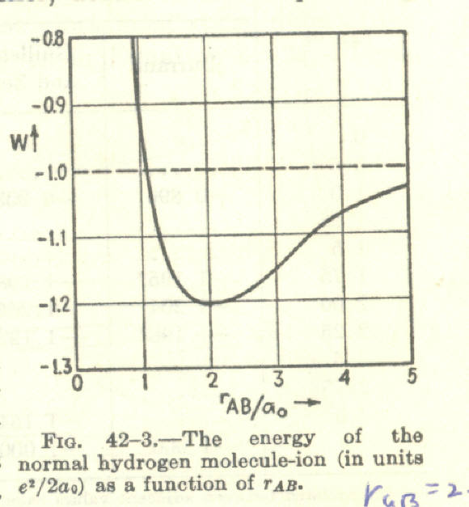

FORTRAN CODE
c H2 + one dimensional model
dimension psi(0:10000) , psinf(0:500) , energy(0:500)
v(x)=-Z/x - Z/abs(x-R) + 1./R
g(x,i)=-2.*(e -( v(x)) )*psi(i)
pi=2.*asin(1.)
z=1.
R=10.
e=-Z**2
efinal= 0.
niter=150
de=(efinal-e)/float(niter)
escale=27.2109
c print*,'escale,e=',escale,e
do 110 iter=1,niter
xlim=R
nstep=6000
dx=xlim/float(nstep)
c if(niter.eq.1)goto 125
c xlim should go beyond the classical turning point where e=V(x)
c initial condtions psi(x)=x**al , psi'(x)= al*x**(al-1.) al.ge.1.
c for al=0. psi'(x)=-1.
c for al=0. psi(0)=1. psi(1)=psi(0)
psi(0)=0.
psi(1)=psi(0) + dx
do 100 i=2,nstep
x=dx*float(i)
psi(i)=dx**2*g(x-dx,i-1)+2.*psi(i-1)-psi(i-2)
c print*,'e,g,psi(i)=',e,g(x-dx,i-1),psi(i)
100 continue
energy(iter)=e
psinf(iter)=psi(nstep)
e=e + de
110 continue
print*,' R (inter atomic distance)=',R
125 do 20 i=1,niter
print 120,energy(i),energy(i)*escale,psinf(i)
20 continue
120 format(3x,'e(au),e(ev), psifin=',3(4x,e11.4))
print*,' '
c examine the wave function and delete any ..diverging part at infinity
c before normalizing
c if(totalrun.eq.1.)then
c call plotwave(psi,alfa,alfa2,pi,nstep,20,dx)
c nstep2 is decided examining call plot
c nstep2=2550
c call anorm (psi,pi,nstep2,dx)
stop
end

subroutine vee(anel,f1s,f2s,f2p,alfa,alfa2,pi,nstep,dx,ajcoul)
b(anel)=.7937*(anel-1.)**(2./3.)
c b(anel)=.5424*anel**(2./3.)
psi1s(x)= sqrt(alfa**3/pi)*exp(-alfa*x)
psi2s(x)= sqrt(alfa2**3/(32.*pi))*(2.-alfa2*x)*exp(-alfa2*x/2.)
psi2p(x)=sqrt(alfa2**5/(96.*pi))*x*exp(-alfa2*x/2.)
rho(x)=f1s*psi1s(x)**2 + f2s*psi2s(x)**2 + f2p*psi2p(x)**2
veerho(x)=B(anel)*rho(x)**(4./3.)*x**2
sum=0.
do 10 i=1,nstep
x=dx*float(i)
sum=sum+veerho(x-dx)+ veerho(x)
10 continue
sum=sum*4.*pi*dx/2.
ajcoul=sum
return
end

subroutine plotwave(psi,alfa,alfa2,pi,nstep,ns,dx)
dimension psi(0:10000)
psi1s(x)= sqrt(alfa**3/pi)*exp(-alfa*x)
psi2s(x)= sqrt(alfa2**3/(32.*pi))*(2.-alfa2*x)*exp(-alfa2*x/2.)
psi2p(x)=sqrt(alfa2**5/(96.*pi))*x*exp(-alfa2*x/2.)
do 10 i=0,nstep,ns
x=dx*float(i)
print 100 ,i,x, sqrt(alfa2**3/(32.*pi))*2.*psi(i),psi2s(x)
10 continue
100 format(2x,'i,x,psi,psi1s=',i4,2x, 3(3x,e11.4))
return
end

